Name: Binish Bhattarai

Student ID: U3249256

Unit Name: Data Science Technology and Systems

Email: [U3249256@uni.canberra.edu.au](mailto:U3249256@uni.canberra.edu.au)

## Assignment I

1. Link to the Tableau Dashboard

* [Sydney Restaurants-Tableau Dashboard | Tableau Public](https://public.tableau.com/app/profile/binish.bhattarai/viz/SydneyRestaurants-TableauDashboard/Dashboard1?publish=yes)

1. The results of the (regression and classification) trained models on the test data. These results must be listed in two tables: one for the regression and another for the classification

### REGRESSION MODELS:

|  |  |
| --- | --- |
| MODEL | MSE |
| MODEL_1 | 0.090 |
| MODEL_2 | 0.090 |

### CLASSIFICATION MODELS:

|  |  |
| --- | --- |
| MODEL | ACCURACY |
| RANDOM FOREST | 0.865 |
| K-NEAREST NEIGHBORS | 0.874 |
| SUPPORT VECTOR MACHINE | 0.810 |

### 

1. The list of commands you have used to deploy your source code to the GitHub repository

* Git hub : [bbhattarai127/dsts-assignment-1 (github.com)](https://github.com/bbhattarai127/dsts-assignment-1)

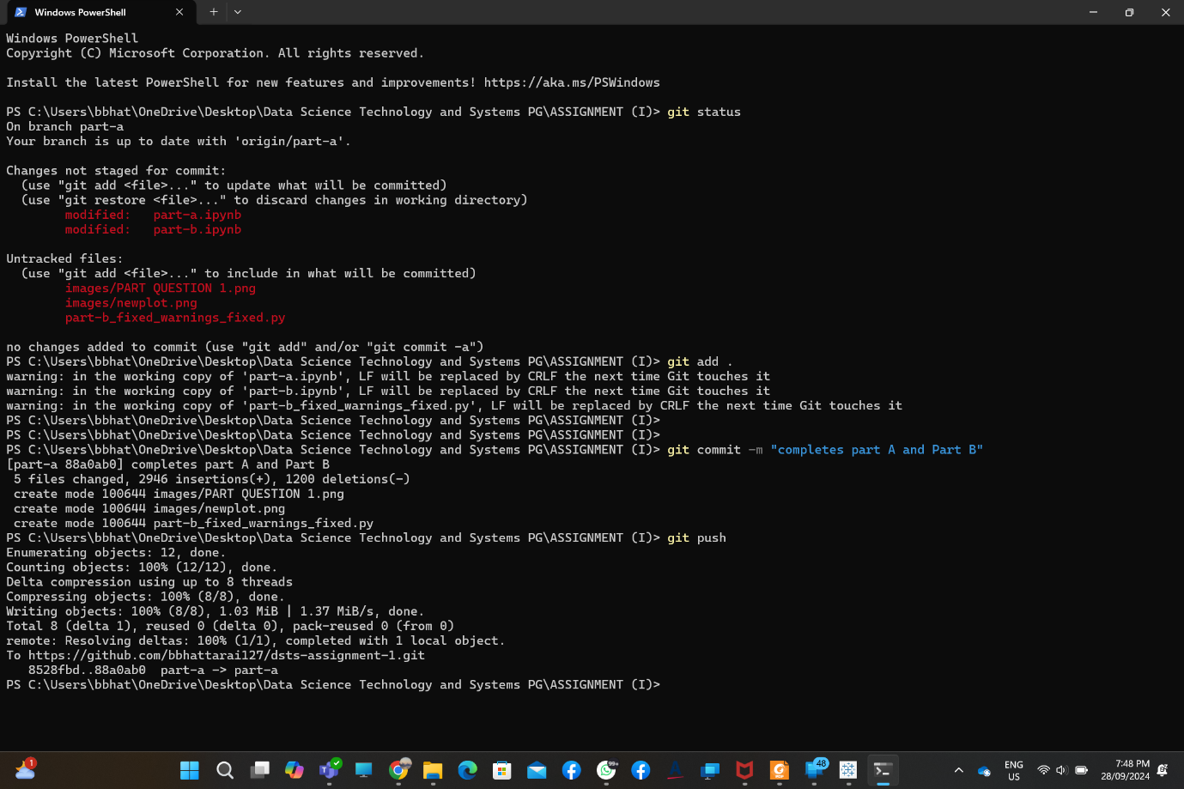

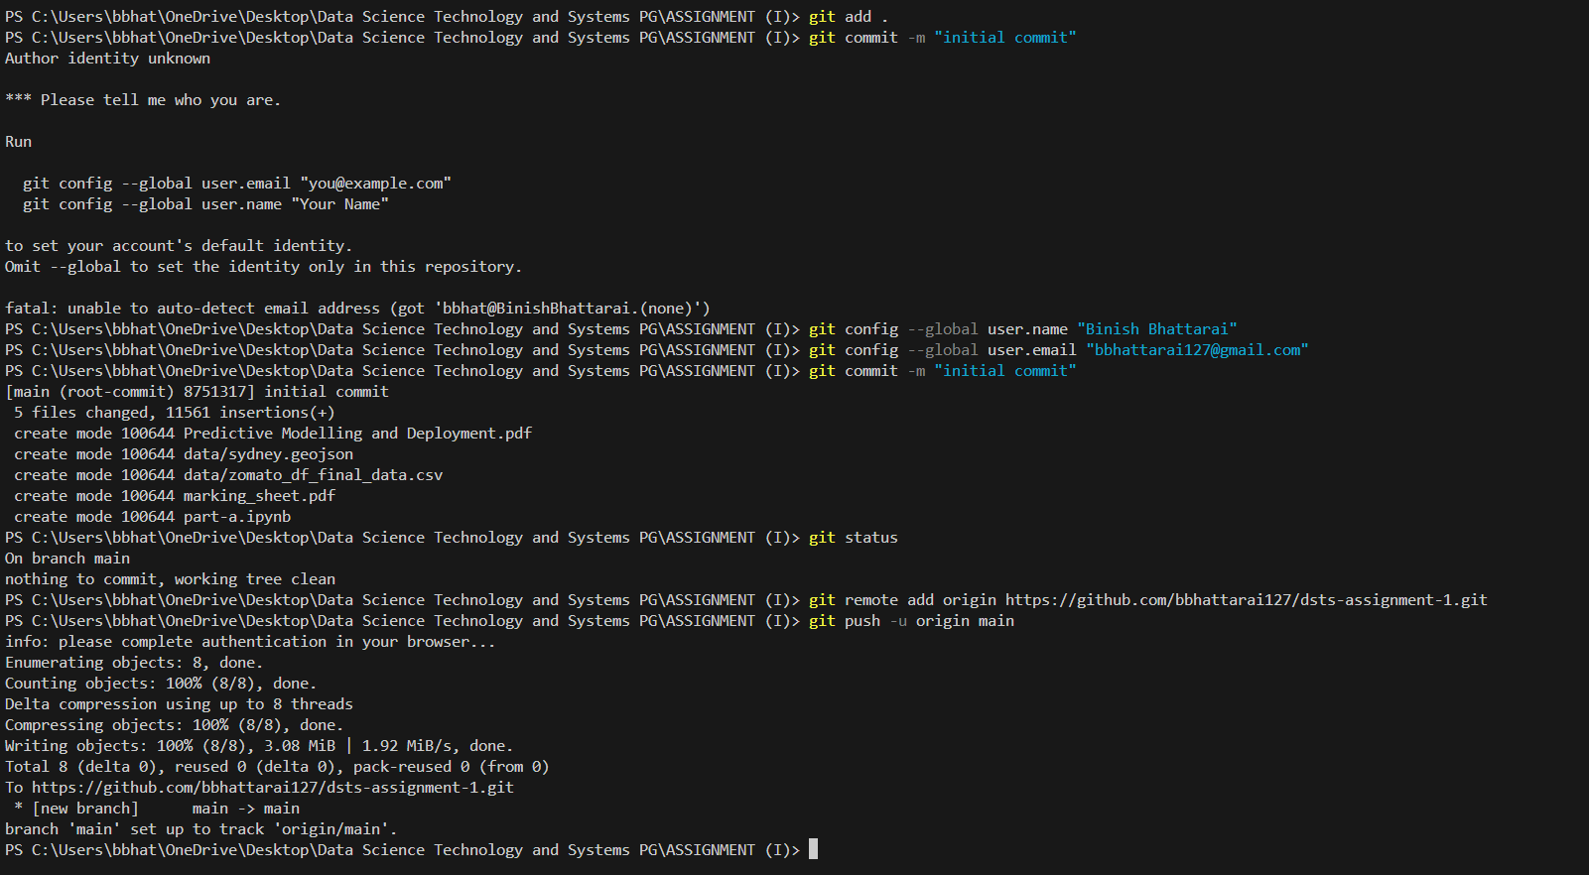

1. The list of commands you have used to create and push the Docker image to the

Docker Hub

Docker Link :

1. The Link of the source code you have deployed on GitHub (please add me as a

collaborator; my GitHub account is [radwanebrahim@gmail.com](mailto:radwanebrahim@gmail.com))

* [bbhattarai127/dsts-assignment-1 (github.com)](https://github.com/bbhattarai127/dsts-assignment-1)

1. The link to the Docker image you deployed on the Docker Hub

* <https://hub.docker.com/r/bbhattarai127/dsts-models>